**Lab 02: Problem Modeling and Encapsulation**

Lê Quốc Tuấn 20236008

USE CASE DIAGRAM:

UML Class Diagram for Use Cases Related to Cart Management:

Code Aims Class:

Code DigitalVideoDisc Class:

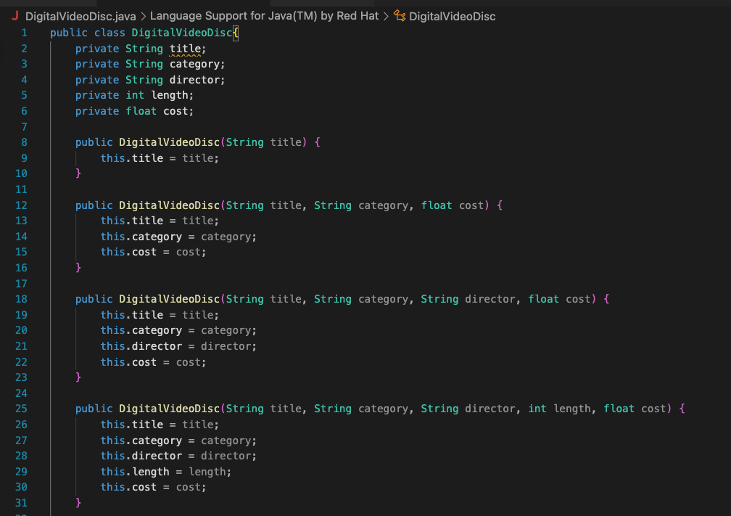

Code Cart Class:

